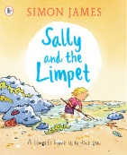

Welcome

Pack

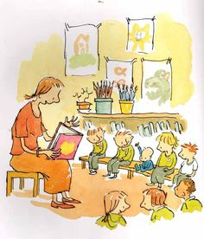

Simon James Class



July 2018

Dear Parents,

It was so lovely to spend some time in our new class these past two days. We had a really great time and can’t wait to get going in September.

Please take time to read the welcome pack through with your child, particularly at the end of the summer holiday. This will really help your child with their transition into Simon James Class.

Our class webpage will be up and running from the beginning of the summer holiday. From September, it will be updated at the end of each week with information about what we’ve been up to and what’s to follow.

If you have any questions, please do not hesitate to contact us. Our door is always open.

Please email any questions or pictures of your summer holidays to smooney@holycross.plymouth.sch.uk. We would love to see all of the amazing things you get up to over the summer!

Kind regards,

Miss Mooney, Mrs T Jarvis and Mrs K Jarvis



Welcome to Simon James Class

**My teacher will be Miss Mooney**

She is really looking forward to helping you to grow and learn.



**Mrs K Jarvis and Mrs T Jarvis are my teaching assistants**

They are kind and helpful and looking forward to getting to know

each and every one of you.

They will take care of me when I am at school.

I can ask them for help with anything!



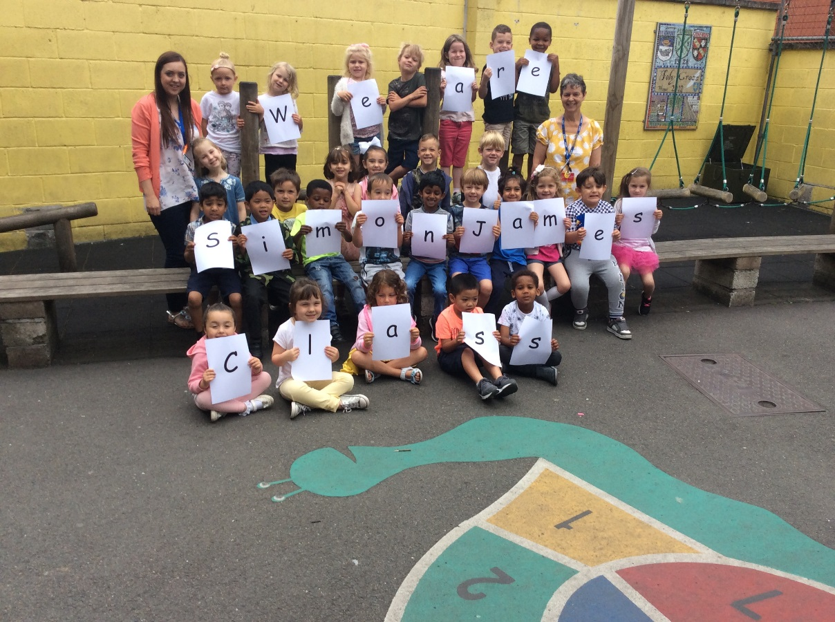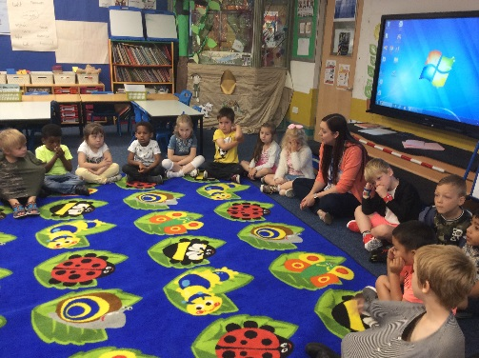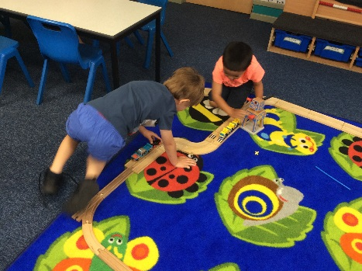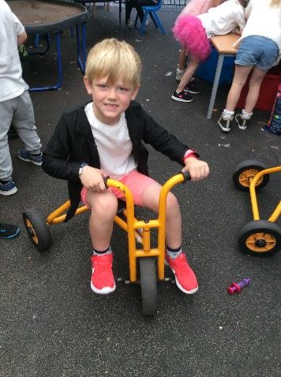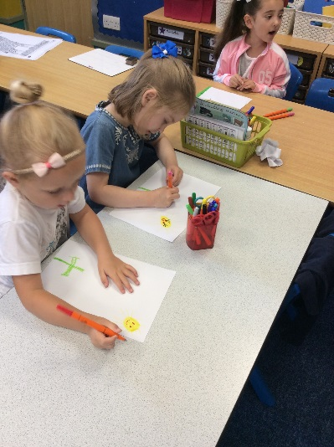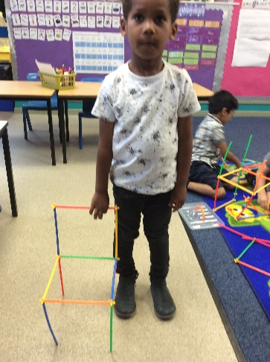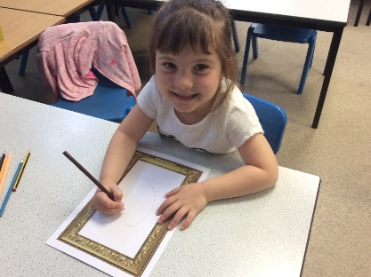

We cannot wait to be back together again in September.

This is what we did on our transition morning!



**My Morning Routine**

1. I come into school via the middle playground.
2. I go to my classroom and put away my reading folder and water bottle.
3. I hang my coat and bag on my peg in the cloakroom which is inside my new classroom.

I begin my quiet morning activity



**Summer Home Learning Challenges**

**Looking for things to do?**

**Try some of the following fun summer activities.**

1. Special bag challenge! (compulsory)

Decorate the bag and fill it with things about you!

It could be lego, photographs, whatever you want. The more imaginative the better!

1. Join the local library and complete the summer reading challenge.

<https://www.plymouth.gov.uk/libraries/childrenandyoungpeople/summerreadingchallenge>

1. Research my first topic: Where is Barnaby Bear?

Barnaby Bear has been spotted all around the UK. Learn the countries of the UK and explore possible places he would like to visit.

1. Enjoy precious time with my family and friends!



**What do I need to bring to school with me every day?**

* Waterproof coat
* Bag for my belongings (book bag)
* Water bottle
* School PE kit - We ask that this is left at school. We will return it when it needs washing!

**School PE Uniform**

Holy Cross white printed t-shirt

Royal blue shorts

Slip on plimsolls (no laces)

All items of the school PE uniform can be purchased at; The National School Wear Centre in Mayflower Street Plymouth or Trutex at Plymstock (near The Range)

**What will my teacher provide?**

* **Reading folder**

During the first week each child will receive a reading folder and a reading book. Please remind your child to bring this to school every day. We will place any letters for you in here so please check them each night. Put letters and slips for us in here- we check them daily.

* **A friendly smile!**



I will care and support your child through their next year at Holy Cross. Please let me know if you have any questions, concerns or worries. You are welcome to contact me in the way which suits you best: reading diary, letter in book bags, phone call or email.

