Name:______________________________ 17.09.2018

In year 2 I need to be able to compare numbers using <, > and =.

< means less than

> means more than

= the same as

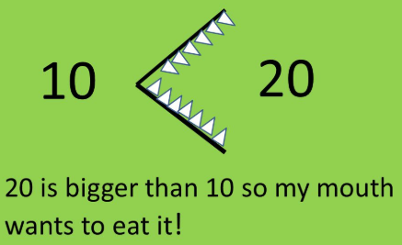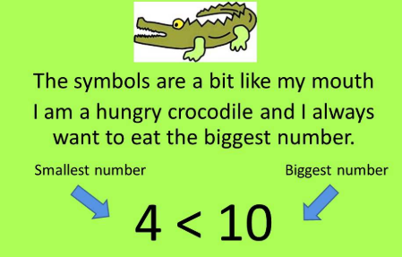

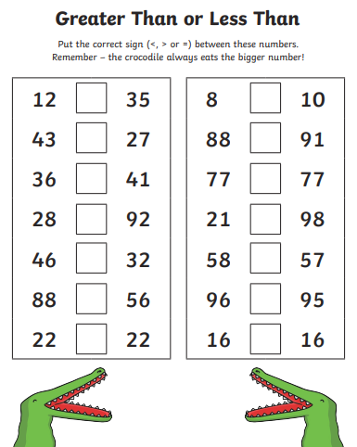
Want to do more?
Roll a dice twice. When the numbers are added, are the more or less than 10?
You may want to record your answers like this?
3 + 5 < 10
How many times did it take for you to make 10?

Please hand in by Monday 24th September 2018.

